Candidate & Voter Agents in 3D Political Spectrum Space

Harold Walbert Christopher Nguyen Namloc Nguyen Jessie Park

## Abstract:

In this paper we seek to model an electoral process where voters choose candidates based on the voter's self-interest. We construct an agent-based model using three dimensions of empirical distributions of ideology. Over the course of a campaign, voters update their preference for a candidate based on their unique position in their social network and their unique position in 3D political ideology space. Voters can influence other voters’ perceptions of the likelihood that their preferred candidate will win. In addition, candidates are able to respond to the "polls" they take of voters and are able to make known updated policy positions in an effort to find more voters.

Keywords: agent based modeling, 3D political spectrum, voter behavior, political ideology, dimensional analysis, competition, Hotelling Model, Public Choice

# Introduction

In an electoral process, voters choose candidates based on their while candidates want to receive votes from voters. We construct an agent-based model under the assumption that electoral preferences of individual voters change over the course of a campaign due to social interactions and the influence of local and global information. In these networks, voters can influence other voters, and vice-versa, in how they ultimately vote.

The main objectives of this paper are to further the conversation about party competition from both the voter and candidate perspectives as well as understand distributions of voter preferences that may follow different distributions and may be clustered over a wide variety of political dimensions. Additionally, this paper will allow for the political spectrum to be more complex than the usual one or two-dimensional spectrums that are common in the literature. Agents follow a variation of the Hotelling model. While there are many examples and discussions of the Hotelling model, little has been done to apply the Hotelling model to different dimensions. The current research has targeted two-dimensional applications of the Hotelling model to determine optimal locations and prices, and analyzing the effects of this two-dimensional competitive model. (Larralde, Jensen, & Edwards, 2006; Veendorp & Majeed, 1995) Brierly (2008) married the Hotelling model and the Salop model and took it to the n-th dimension to formulate a generalization that can be applied to location theories and the median voter theorem. By using empirical data and agent-based modelling, we identify three axes on the political spectrum which will give voters the environment to choose their preferred candidate and give candidates the space in which to operate in order to capture the votes of the average voter. For Laver and Sergenti (2011), their most important finding was that parties continually adapt policies as a means of procuring more votes (“saticiticing”).

“Insatiable vote seeking party leaders continually adapt party policy in a restless search for more votes, regardless of their party’s current vote share… Our conjecture on this refers to the exploration-exploitation trade-off we encounter in many adaptive behaviors. Insatiable leaders engaged in dynamic multiparty competition, always explore for more votes. Even when they are doing very well indeed, they want to do even better. In contrast, satiable party leaders always exploit favorable short-run situations, never perturbing these in search of even more votes. This striking result is revealed by our dynamic ABM of multiparty competition, but would be inaccessible using static models analyzed with traditional techniques.” (Laver and Sergenti, 2011)

This paper will proceed as follows:

1. Literature reviews of the current literature as it progresses through the economic foundations necessary for our experiment and a relevant literature review of research on the political spectrum, political ideology, measurement, and visualization. The logic of the basic mathematical model behind downs paradox will also be covered.
2. An examination of the data, methods & analysis that make up this paper. This will include cleaning and analysis of the empirical data, model specification, etc.
3. Results and findings.
4. Discussion of the results and findings.

## Literature Review

Harold Hotelling (1929) in "Stability in Competition" hints at, what Duncan Black later formalizes as, the median voter theorem which states that to capture the majority, the outcome must be preferred by the median voter. Hotelling first makes the argument using the location of businesses on a straight path – both of whom will alter not only their prices but their location along the path to attract more customers. The businesses will lower their prices and begin to converge on the one-dimensional plane in an effort to seem more appealing to customers. (Hotelling, 1929) The classic example of two ice cream vendors on a beach boardwalk lends a hand in explaining the behavior that Hotelling noticed. Imagine two ice cream vendors on a beach boardwalk; they offer the same flavor and price, so beachgoers go to the closest vendor. The question the vendors have to solve is where do they locate themselves to get the most customers. The Hotelling model shows that there is a natural tendency to converge towards the middle. While the application was to analyze behavior of the firm in capturing the market, Hotelling does recognize the shift in political stances between the Democratic Party and the Republican Party.

Almost 20 years later, Black (1948) in "On the Rationale of Group Decision-making" refines and formalizes the behavior Hotelling noted in political stances and majority voting into the median voter theorem. Granted two constraints, the position of the median voter is a Nash equilibrium - at that point, nothing is gained by moving away from that position. The two constraints are: preferences are single-peaked and preferences are only considered over a single dimension. (Black, 1948) For our experiment, we assume that the preferences of the voters are single-peaked in that they will gain the most utility by voting for their candidate. Where this experiment strays is with the second constraint. The median voter theorem is restricted to a single dimension since an equilibrium cannot be reached in situations considering multiple dimensions. However, following in the footsteps of Brierly (2008), without marrying the Hotelling model to the Salop model, we pivot and turn our focal points to the Hotelling model and Downs paradox to conduct spatial analysis of voter behavior.

Downs paradox, also referred to as the paradox of not voting, states that a rational, self-interested voter will not vote if the cost of voting is greater than the expected benefit of voting. Since the probability that the voter gets into a car crash on the way to the voting poll is higher than the probability that the voter will cast the deciding vote, the voter will most likely not vote since the cost of voting will be greater than benefit. (Downs, 1957ab; Feddersen, 2004) However, that is not the behavior that is exhibited. Voters will go through inclement weather, overcome the distance to the voting poll, wait in long lines, spend time pondering about who to vote – all of which are factors of cost in voting – to go vote. "This finding suggests that voters participate because they hope to influence the ultimate outcome of the election." (Feddersen, 2004)

The main equation that is used to determine if an agent votes or not in any election is given by:

$$P×B+D>C$$

Where $P$ is the subjective probability that one's vote will make a difference in the outcome, $B$ is the difference between the distance between the agent that is not my candidate and the agent that is my candidate, $D$ is the private benefits from the act of voting, and $C$ is the cost of voting. $P$ itself is mathematically defined as:

$$P=\frac{3e^{-2(N-1){(F-0.5)}^{2}}}{2\sqrt{2π(N-1)}} where F=avg(B) of inlinks$$

and represents the agents’ individual belief that their preferred candidate will win. $N$ is the number of voters participating in an election. As $N$ increases the law of large numbers tends to apply, and we will see $P$ approach one half. The law of large numbers necessitates such an outcome should occur assuming an underlying Gaussian distribution. $B$ is the overall gain from the differences in ideological positioning in terms of utility. In graphical terms, it is the difference in displacement of the preferred candidate to the voter subtracted from the displacement of the non-preferred candidate to the voter. The difference is the utility gained from voting. $D$ is the private benefit of the actual act of voting, which could be defined as a subsidy, favorable legislation, pride in fulfilling civic duties, other private benefits, and etc. The act of voting may result in a positive value $D$, which is not necessarily tied to any legislation that gets passed (it just has to be perceived as beneficial), or it may help avoid a negative value $D$, which may be the feeling of guilt if one does not vote. Lastly, $C$ is defined as the costs of voting. Costs could include anything from typical travel costs accrued in travelling to a voting booth to opportunity costs incurred due to loss of the chance to partake in all other substitute options. When the probability of the preferred candidate winning by the utility a voter gains in picking a candidate is greater than the costs of voting less his personal gains from voting, the agent votes. If this does not hold, our agent should not rationally vote. This is the “Rational Voter Hypothesis” termed by Downs.

For reasons of tractability, our political spectrum has always been one-dimensional, with two extremes. When we move to dimensions higher than one, the problems and issues become more complicated and increasingly difficult to pin point and even harder to solve. Benoit and Laver find that:

“in most countries, the first principal dimension is typically represented by a classic pattern of left-right political competition. In some, however – Turkey and Israel, for instance – the first underlying dimension may have comprised other political issues not traditionally associated with the classical left-right political spectrum, such as foreign policy, immigration, nationalism, or religion. Furthermore, the precise policy content of the principal left-right axis of political competition varies considerably from country to country. Just as there is no single ‘best’ representation of the policy space in any given country, there is no single ‘best’ definition of the main left-right axis of political competition that is substantively portable…” (Benoit, 2006)

The variations of what we deem as left or right can be generalized, but cannot be used as a blanket statement to describe groups of people in specific countries. A group of people in a certain context cannot always be brought out of their situation and generalized using incomplete knowledge. Certain patterns may arise and correlate themselves with policies, but that must be done on a case by case basis. Benoit and Laver state that policy is a good tool in trying to categorize a current regime’s left-rightness on a spectrum, but using regression data, the R-squared is below 0.5 for countries with high sense of nationalism. They think that a third dimension, “‘local’ policy dimension” may explain what socioeconomic policies, alone, cannot. (Benoit, 2006) They are right in saying that even a two-dimensional spectrum probably is not enough, less a one-dimensional left-right model.

Laver have found that up to three independent policy dimensions can be sufficient to capture most of the important information. They use Voronoi tessellation (Voronoi diagram), to describe areas and geometric problems of Competitive Spatial Location (changing positions as a means of reaching objectives while using information to make decisions about where to move). Spatial models based on describing politics as leaning towards the left or the right is our basis for research about political competition. (Laver and Sergenti, 2011)

Johnston and Feldman believe that there is an inability for a heterogeneous man to be categorized merely using a single unidimensional spectrum.” The multidimensionality of preferences implies that self-placement along a single dimension is insufficient to account for the variety of ideological perspectives in the public." The two of them also show that there is a myriad of determinants that factors into a person's ideological grouping when there are multiple dimensions. "We have shown that modeling the predictors of ideology yields substantially different conclusions in a two-dimensional model than the one-dimensional model." (Feldman, 2013) This is because certain variables only affect a single movement of travel, but others move across multiple dimensions. Castle and Mair (1984) noticed that "there are many parties whose primary goals cross-cut the Left-Right ideological dimension and whose names may reveal little concerning their ideological position." They come up with three strategies to identify location-scale: first is to read closely what is put out by the country's leading "experts" (media, academics); second is adding "ad hoc decision rules," to the first, that specifies party location; lastly, they say to use surveying techniques to poll people in order to gauge their political ideologies. (Castle, 1984) This is not enough to explain ideology and at the same time it is too much. A poll can create and whichever way a person votes on each issue could be a spectrum in of itself, creating a possibly infinite-dimension. The problem is that, while this is very specific, it is not particularly useful in trying to generalize ideology. Instead of adding a multitude, one could possibly claim that there are only three dimensions that truly matter when trying to describe the typical rational voter. Using just three for a model limits what needs to be accounted for, while still maintaining a higher level of truth.

Michael Laver and Ernest Sergenti have examined politics as a dynamic process. They have laid out much of the basis to how we are creating our model.

“It evolves. It never stops; It is never at, nor en route to, some static equilibrium. Politics evolves. Politics is complex. Political outputs today feedback as input to the political process tomorrow…Politicians are diverse. In particular, different politicians attack the same problem in different ways…Politics is not random. Systematic patterns in political outcomes invite systemic predictions, making a political science" possible." (Laver & Sergenti, 2011)

They define multi-party competition as competition between greater than two parties. For our research, we will examine multi-party competition between two parties. Agent based modeling will be used to model competition, relationships, and intricate networks between agents and candidates. According to Laver and Sergenti (2011) the birth and death of political parties are endogenous to their model. Party leaders can be comfortable or uncomfortable and there can be different survivor thresholds. Punishment and rewards are administered by voters via “ticks”. There are two types of ticks. During campaign ticks, politicians make decisions about party policy to respond to new information (i.e. Polls). For election tick, voters make decisions about who to vote for. Therefore, parties may die and new parties may be born.

In Laver and Sergenti’s model, they assume that voters’ preferences are characterized by an ideal policy position in n-dimensional policy space. This describes how different policy positons differ from the voters’ ideal points. The distance between policy positions are Euclidian. A crucial factor of the model is a description of the distribution of voters’ ideal points. For policy dimensions of interest, they assume the overall population are normally distributed. Their reason for assuming a normal distribution is that an n-dimensional Euclidean real space extends to infinity in all directions. Real voters are not thought of to have infinitely extreme ideal policy points. However, the normal distribution assumption is an important restriction on possible distributions of voters’ ideal points:

“For example, it excludes the possibility that ideal points are uniformly or arbitrarily distributed, since these distributions imply we are just as likely to find someone with an infinitely extreme ideal point as someone closer to the center. Precluding infinitely extreme voters thus implies that densities of voter ideal points asymptotically approach zero in every direction as policy positions become more extreme. This implies distributions that are in this sense bell-shaped, at least at the extremes.” (Laver and Sergenti, 2011)

The party policy positions closest to the voter’s ideal point wins the voter’s vote.

## Method of Analysis

We begin by asking the question: "Can we model voting agents where these agents may take into account up to 3 dimensions of political ideology? Furthermore, can we give these agents an empirical basis for the distributions they take?" An agent-based model is ideal for looking at questions where the interactions of individual, unique decision makers effect the macro level emergent outcome. It allows simulations of interactions of autonomous individuals (the voters) in an environment, in order to determine the overall effect of the outcome. This paper does this by using data comparing political parties. (Swank, 2013) Data includes Country and Year level detail with information on the whether it was an election year along with variables for political classifications. (Castles & Mair, 1984) There are 28 variables giving vote/seat/cabinet portfolio percentages for the following political classifications: Left, Right, Christian Democratic, Centrist Christian Democratic, Center Party, Right Wing Populist, and Left Libertarian. After incomplete observations are removed there are 1,226 observations left for the years 1950 to 2011 for 21 countries.

Table of Countries and frequency of observation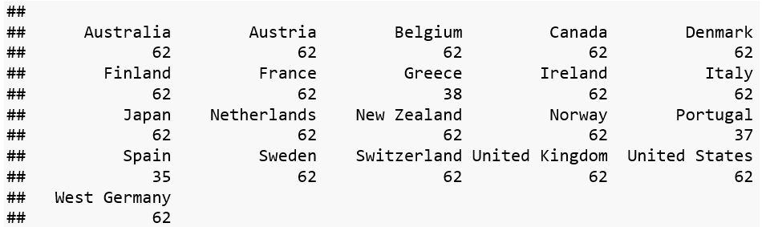

Table of Years observed and the frequency of the observation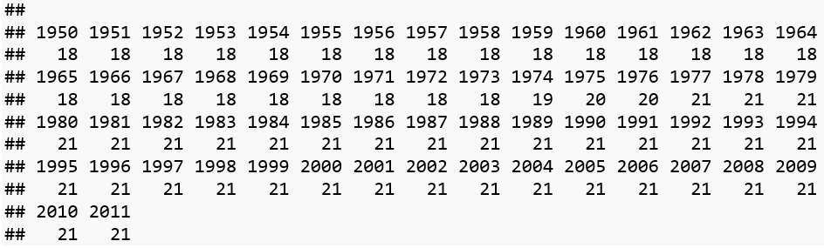

The data is transformed into a dissimilarity matrix using the method described by Gower (1971). Since the dataset contains multiple classes of data we need to use a method that allows distance calculation across multiple classes. Once this matrix is calculated, a Principal Components Analysis (PCA) is used to reduce the dimensionality of the original transformed dataset. The first three components of the PCA explain approximately 80% of the variance. Adding two more components only gets us up to 90%.

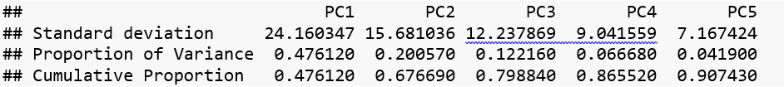

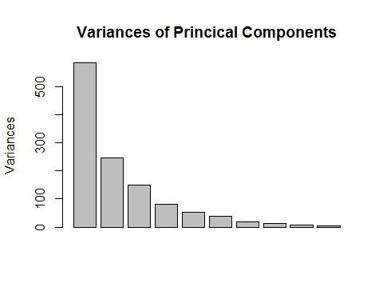

A K-means clustering algorithm is used on the dissimilarity matrix to calculate clusters. Clusters are calculated for 2 through 20 clusters. (Hartigan & Wong, 1979)

I take the rotations of the first three prinical components as the first three dimensions of political ideology that each person, country, agent has. Understanding the distributions, what Laver and Sergenti (2011) call "voters ideal points" of political ideology could shed light on how voting and elections work. We want to take a look at these first three dimensions. But before we work on all three dimensions let’s take a look at the first two. Different dimensions of political ideology are important for understanding how voters behave. Here is a look at the distributions of all three dimensions along with their correlations.

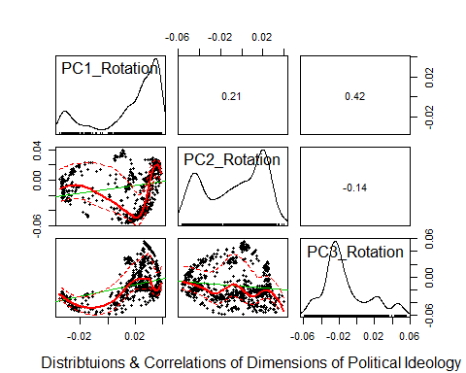

The resulting empirical distributions cannot be described as appearing to follow a normal distribution. Principal Component 2 appears to be distributed in a bi-modal way. Plotting these dimensions can show us how the different distributions are related. Adding a third dimension to the visualizations can change the way we understand how ideology is distributed. The following two visualizations show how the addition of a third dimension can shed more light on the spatial distribution. Adding the third dimension can give a better understand about political ideology space.

First we look at only two dimensions

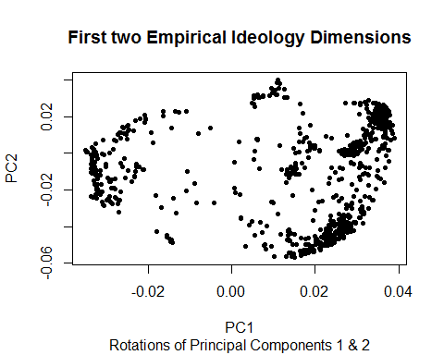

The plot below shows all three dimensions in one graph.

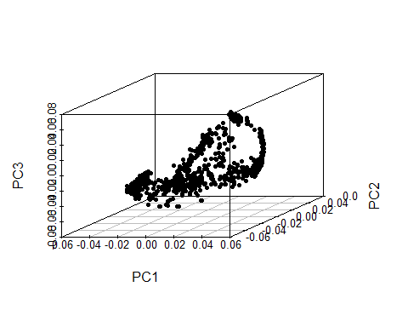

This is the same plot as above with each observation colored by Country. Notice that countries can be seen to have distinct groups or clusters in separate parts of ideology space. These differences can take place on one or more dimensions.

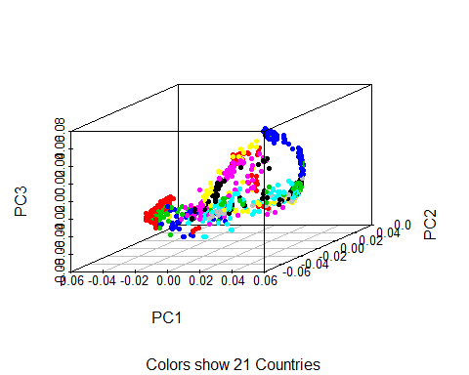

Below are plots of several individual countries locations on this spectrum.

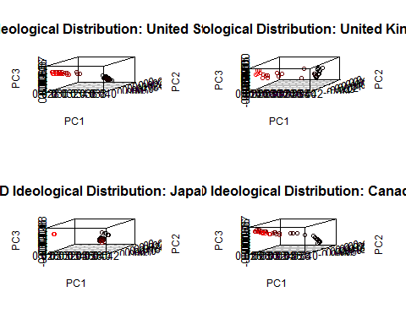

Although political ideology is a continuous spectrum, political parties exists in a much more binary space. They describe themselves as "left" vs. "right", "authoritarian" vs. "libertarian", and "conservative" vs. "liberal". I use K-means clustering to understand the different groups or communities (i.e. political parties) that the data suggests might exist. (Hartigan & Wong, 1979) The graph below shows all three dimensions of political ideology and colors each observation according to the cluster to which it belongs.

Examples are shown for 2 & 3 clusters.

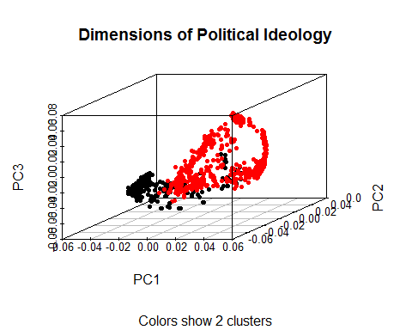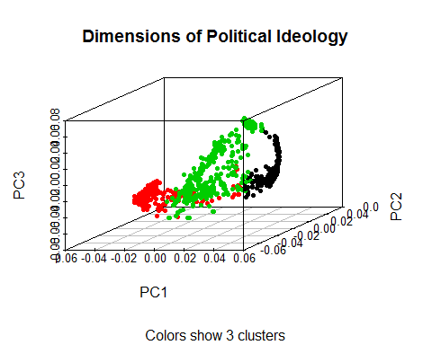

## Description of the ABM

The model starts with the import of a network generated according to a random, scale free or small world distribution. The nodes in this network represent the voter agents that are instantiated with political ideology coordinates drawn according to the empirical data described in the previous section.

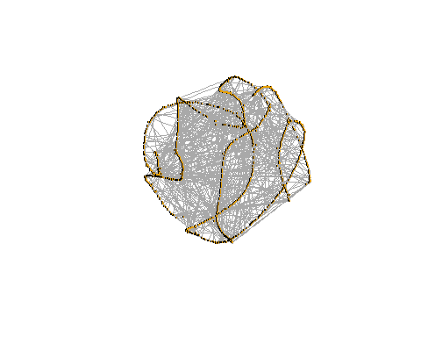 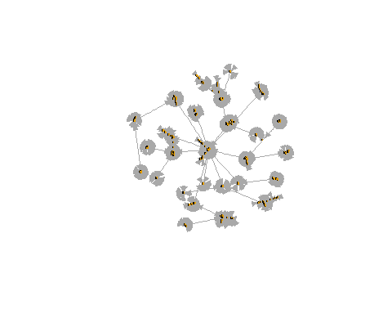

Small World network of voter agents Scale Free network of voter agents

There are two candidate agents that start out at random starting political ideology coordinates.

There are five variables that each voter agent must calculate. Three of the variables (*P*, *B*, and *F*) are calculated and updated as the simulation is run. The other two variables (*C* and *D*) are set at the beginning of the simulation and stay the same for the duration of the simulation. The main equation that is used to determine if a voter votes or not is given by: $P×B+D>C$. The variable *P* is each voters’ subjective probability that their vote will make a difference in the outcome. *B* is the difference between the 3D distance between the agent that is not my candidate and the agent that is my candidate, *D* is the private benefits from the act of voting, and *C* is the cost of voting.

P itself is mathematically defined as:

$$P=\frac{3e^{-2(N-1){(F-0.5)}^{2}}}{2\sqrt{2π(N-1)}} where F=avg(B) of inlinks$$

and represents the agent’s individual belief that their preferred candidate will win. *N* is the number of voters participating in an election. As *N* increases the law of large numbers tends to apply, and we will see *P* approach one half. The law of large numbers necessitates such an outcome should occur assuming an underlying Gaussian distribution.

*B* is the benefit from a difference in policy positions between the candidates. *B* is calculated as the 3D distance from the candidate the voter does not support minus the 3D distance from the candidate that the voter does support. Said differently, it is the overall utility gain from the differences in ideological positioning of the candidates should the voters preferred candidate win.

*F* is calculated using each voters individual network. They have two types of voters in their network: voters that support the candidate they support and voters that do not. *F* is a fraction where the numerator is the number of voters in their network that support their candidate multiplied by that voter’s *B* value (how much they would benefit if their candidate wins, i.e. the other voters "fervency"). The denominator is the number of voters in their network that do not support their candidate multiple by that voter’s *B* value. If the voter doesn't have a network large or diverse enough to support this type of analysis, *F* is set to a random normal centered on 0.5.

*D* is the benefits that are unique to each agent should their candidate win. It is the private benefit of the actual act of voting. This could take the form of a subsidy, favorable legislation, pride in fulfilling civic duties, or outright corruption in the government and election system. For the experiments we will assume a low level of corruption that is distributed according to an exponential distribution. This makes a world where most agents have a very low level of private benefits but some voters have large benefits should their candidate win. The minimum value *D* can take is 1 and this is the default if there is no corruption in the model.

Lastly, *C* is defined as the costs of voting. Costs could include anything from typical travel costs accrued in travelling to a voting booth to opportunity costs incurred due to loss of the chance to partake in all other substitute options. If cost is not set to be 0 then it is distributed according to a normal distribution and it is constrained to be greater than or equal to 0.

When the expected value of the private benefits a voter would should their candidate win plus any unique benefits is greater than the cost of voting (i.e. when $P×B+D>C$) the voter will choose to vote should the election occur at that time. When the probability of the preferred candidate winning by the utility a voter gains in picking a candidate is greater than the costs of voting less his personal gains from voting, the agent votes. If this does not hold, our agent should not rationally vote. This is the Rational Voter Hypothesis from Downs and more fully shown by Mueller. (Mueller & Mueller, 1989, pp.348-369)

When the simulation begins running each candidate will take a poll of the voters. Each of their polls is different and unique to the candidate. The candidates divide these polled voters into two groups: voters that support them and voters that do not support them. The candidates can discount the opinions (political coordinates) of the voters that do not support them. After polling the voters and discounting the options of certain voters, the candidate arrives at the position is political spectrum space that they want to move toward. After the poll the candidates change their heading, pitch, and roll to be oriented to the mean positions on each of the three dimensions for the voters that they care about. They move forward toward this position.

This change in positon is noticed by the voting agents and they recalculate their variables for *B*, *F*, and *P*. They are able to change the candidate they support as well as decide if they even want to vote or not (were the election to occur at that moment). This movement of the candidates and the resulting change in the voters’ decisions account for one-time step. During a campaign there can be many instances where candidates can make updated positions knows (i.e. debates or major policy speeches). The length of election seasons varies across countries. This model is run for 20 periods that represent 20 opportunities for candidates to update their positions and for voters to respond. At the end of the simulation the winning candidate is the one that has the larger number of votes. If cost is turned on in the model then the voter turnout will be 100% . If the cost variable is on, then voter turnout will vary depending on the amount of each voter’s cost their estimated benefit.

## Results

Experiments are ongoing but preliminary results show very interesting behavior.

**Voting Cost Experiments**

A sweep of the voting cost parameter was done using no cost, low average cost and high average cost to see what effect this would have on the macro outcomes in the model. This experiment was done 100 time across all network types. When there is no cost, voting participation is always 100% and there is never a flip in what the entire population would want versus what the voting population has decided. When cost is low, voting participation is seen to average 51.9% and it causes the outcome to flip 12 percent of the time. When cost is high voting participation is reduced to an average of 18.2% with flips occurring 45% of the time.

**Candidate Strategy Experiments**

A sweep of different discounts was done to compare the outcomes for a candidate that throws out the opinions of those voters that don’t currently support them versus the outcomes for a candidate that values the opinions of those voters that don’t currently support them. This experiment was run 100 times and done across all three network types. The overall patterns are the same for all networks. One candidate always stays at a value of 0.5 for their discount. This means that they throw out half of the voters in their polls that don’t currently support them. The other candidate either takes a high discount approach (discount = 0.8) or a low discount approach (discount = 0.2). When the world Scale Free, the candidate with discount = 0.2 can expect to win 18% of the time. When they are a candidate with discount = 0.8 they can expect to win 62% of the time. For all network types is appears that the strategy of valuing those voters that don’t currently support you is a better strategy for winning. When both candidates have a value of 1 then we can begin to see behavior that we know is not reflected in the real world where entire groups of voters will swing back and forth between supporting each candidate.

## Conclusion

This paper has shown that we can use empirical data to proxy for latent variables that describe three dimensions of political ideology. Although more work remains to be done to understand the real-world meaning of the axis we have shown that these dimensions are crucial for understand the dynamics of how voters make decisions about who to vote for or whether to even vote or not. We have shown that real world phenomenon like reduced voter participation or flips in the outcome of an election can be attributed to voting costs imposed on voters and that higher costs can significantly reduce voter turnout.

## References

Benoit, & Laver 1949-. (2006). Party policy in modern democracies. London: Routledge.

Black, D. (1948). On the Rationale of Group Decision-making. Journal Of Political Economy, 56(1), 23-34. <http://dx.doi.org/10.1086/256633>

Brierly, A. B. , 2008-04-03 "A Generalization of the Hotelling-Salop Model to M-Dimensions" Paper presented at the annual meeting of the MPSA Annual National Conference, Palmer House Hotel, Hilton, Chicago, IL Online <APPLICATION/PDF>. 2013-12-14 from<http://citation.allacademic.com/meta/p265616_index.html>

CASTLES, F. & MAIR, P. (1984). Left-Right Political Scales: Some 'Expert' Judgments. European Journal Of Political Research, 12(1), 73-88. <http://dx.doi.org/10.1111/j.1475-6765.1984.tb00080.x>

Downs, A. (1957a). *An Economics Theory of Democracy*.

Downs, A. (1957b). An Economic Theory of Political Action in a Democracy. Journal Of Political Economy, 65(2), 135-150. <http://dx.doi.org/10.1086/257897>

Feddersen, T. (2004). Rational Choice Theory and the Paradox of Not Voting. Journal Of Economic Perspectives, 18(1), 99-112. <http://dx.doi.org/10.1257/089533004773563458>

Feldman, S. & Huddy, L. (2014). Not so simple: The multidimensional nature and diverse origins of political ideology. Behavioral And Brain Sciences, 37(03), 312-313. <http://dx.doi.org/10.1017/s0140525x13002562>

Gower, J. C. (1971) A general coefficient of similarity and some of its properties, Biometrics 27, 857–874.

Hartigan, J. A. & Wong, M. A. (1979). A K-means clustering algorithm. Applied Statistics 28, 100-108.

Hotelling, H. (1929). Stability in Competition. The Economic Journal, 39(153), 41-57. <http://dx.doi.org/10.2307/2224214>

Larralde, H., Jensen, P., & Edwards, M. Two dimensional Hotelling model : analytical results and numerical simulations. 2006. <hal-00114288>

Laver, M., & Sergenti, E. (2011). *Party competition: An agent-based model* (Paperback ed.). New York, NY, United States: Princeton University Press.

Mueller, D. & Mueller, D. (1989). Public choice II (1st ed.). Cambridge [England]: Cambridge University Press.

Swank, D. (2013). Comparative Political Parties Dataset: Electoral, Legislative, and Government Strength of Political Parties by Ideological Group in 21 Capitalist Democracies, 1950-2011. Electronic Database, Department of Political Science, Marquette University, <http://www.marquette.edu/polisci/faculty_swank.shtml>

Veendorp, E. & Majeed, A. (1995). Differentiation in a two-dimensional market. Regional Science And Urban Economics, 25(1), 75-83. <http://dx.doi.org/10.1016/0166-0462(94)02075-r>